Jal Rekha Module

Master & Asset Mapping

(Anushravan (RFI), Dhara (Meter Reading), Asset Mapping (GIS), Nirmal (Water Quality))

(Low Level Design Document &
High Level Design Document)



M.P. STATE ELECTRONICS DEVELOPMENT CORPORATION LTD.
State IT Centre, 47-A, Arera Hills, Bhopal-462011 (M.P.)
www.mpsedc.mp.gov.in

Table of Contents
Jal Rekha Project 2
Low Level Design (LLD) 2
1. Introduction 2
2. System Architecture Overview 2
3. Module-wise Design (Summary) 2
4. Entity-Relationship (ER) Diagram 2
5. Sequence Diagram - RFI Workflow 4
6. Sequence Diagram - Meter Reading Workflow 4
7. Class Diagram (Simplified) 5
8. API Contracts (JSON / XML examples) 14
9. Appendix - Table Schemas (DDL style) 16
10. Module-wise Low-Level Design 17
10.1 Anushravan (Inspection & RFI Workflow) 17
10.2 Dhara (Meter Reading & Verification) 17
10.3 Asset Mapping (GIS-based Asset Capture) 18
10.4 Nirmal (Water Quality Monitoring) 18
10.5 Sopan (Work Monitoring & Planning) 19
10.6 Master (Scheme, Components, Villages, Roles) 19
10.7 User Management 20
10.8 Dashboard & Reporting 20
11. Error Handling 21
12. Security 21
13. Sequence Diagrams (to be included) 21

Jal Rekha Project

Low Level Design (LLD)

1. Introduction
This Low Level Design (LLD) document provides detailed technical specifications for the Jal Rekha project. It includes database design (ER diagram), sequence diagrams for core workflows, class diagrams, API contracts in JSON/XML, and component-level design to guide development and testing teams.

2. System Architecture Overview
- Frontend: ReactJS/Angular for web dashboard and GIS visualization.
- Mobile: Android (Java/Kotlin) with offline sync (SQLite/local storage).
- Backend: RESTful APIs using Spring Boot or .NET Core.
- Database: PostgreSQL + PostGIS for spatial data.
- Authentication: JWT tokens; RBAC for authorization.
- Hosting: Cloud with load balancer, backups, and DR.

3. Module-wise Design (Summary)
Modules covered: Anushravan (RFI), Dhara (Meter Reading), Asset Mapping (GIS), Nirmal (Water Quality), Sopan (Work Monitoring), Master, User Management, Dashboard & Reporting.

4. Entity-Relationship (ER) Diagram
Core entities illustrated: user_master, scheme_master, component_master, meter_master, meter_reading, rfi_master, rfi_inspection, asset_master, water_test, work_plan.
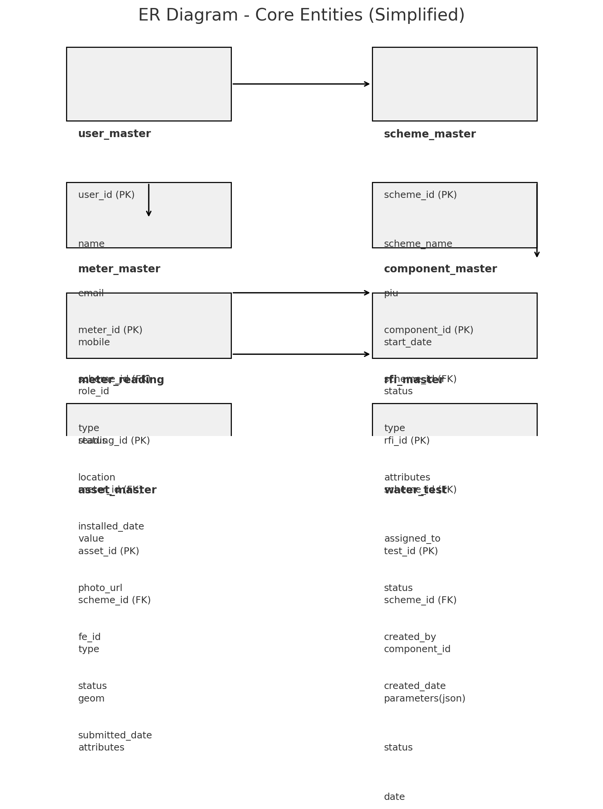
Figure: Simplified ER diagram showing core tables and relationships.

5. Sequence Diagram - RFI Workflow
Sequence: PIU/User assigns RFI → Field Engineer receives and submits inspection → SQC/TPIA/GM reviews and approves/rejects.
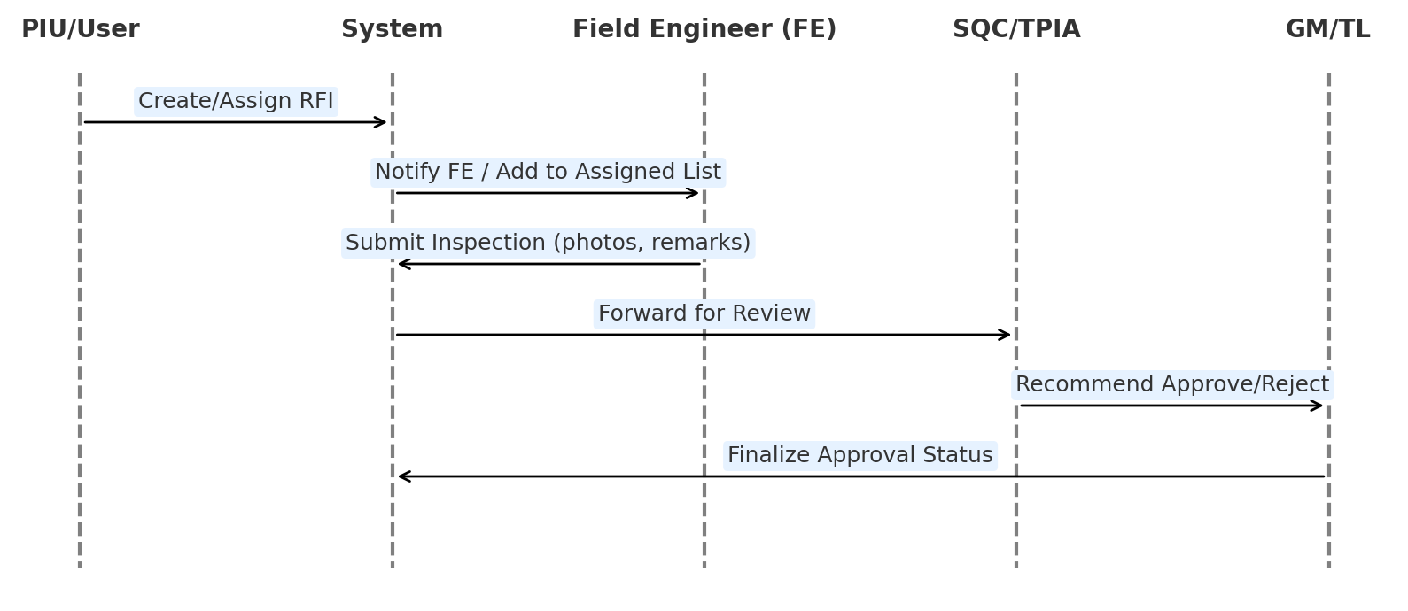

6. Sequence Diagram - Meter Reading Workflow
Sequence: Admin registers meter → Task assigned to FE → FE records reading on mobile (offline support) → Syncs → GM verifies/rejects.
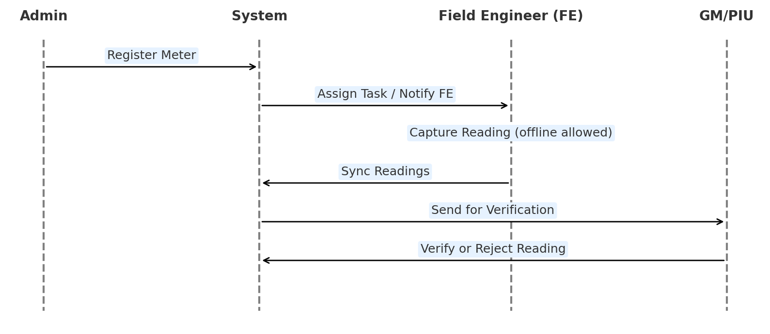

7. Class Diagram (Simplified)
Classes: User, Scheme, Component, Meter, MeterReading, RFI, Asset, WaterTest. Attributes and primary methods shown.
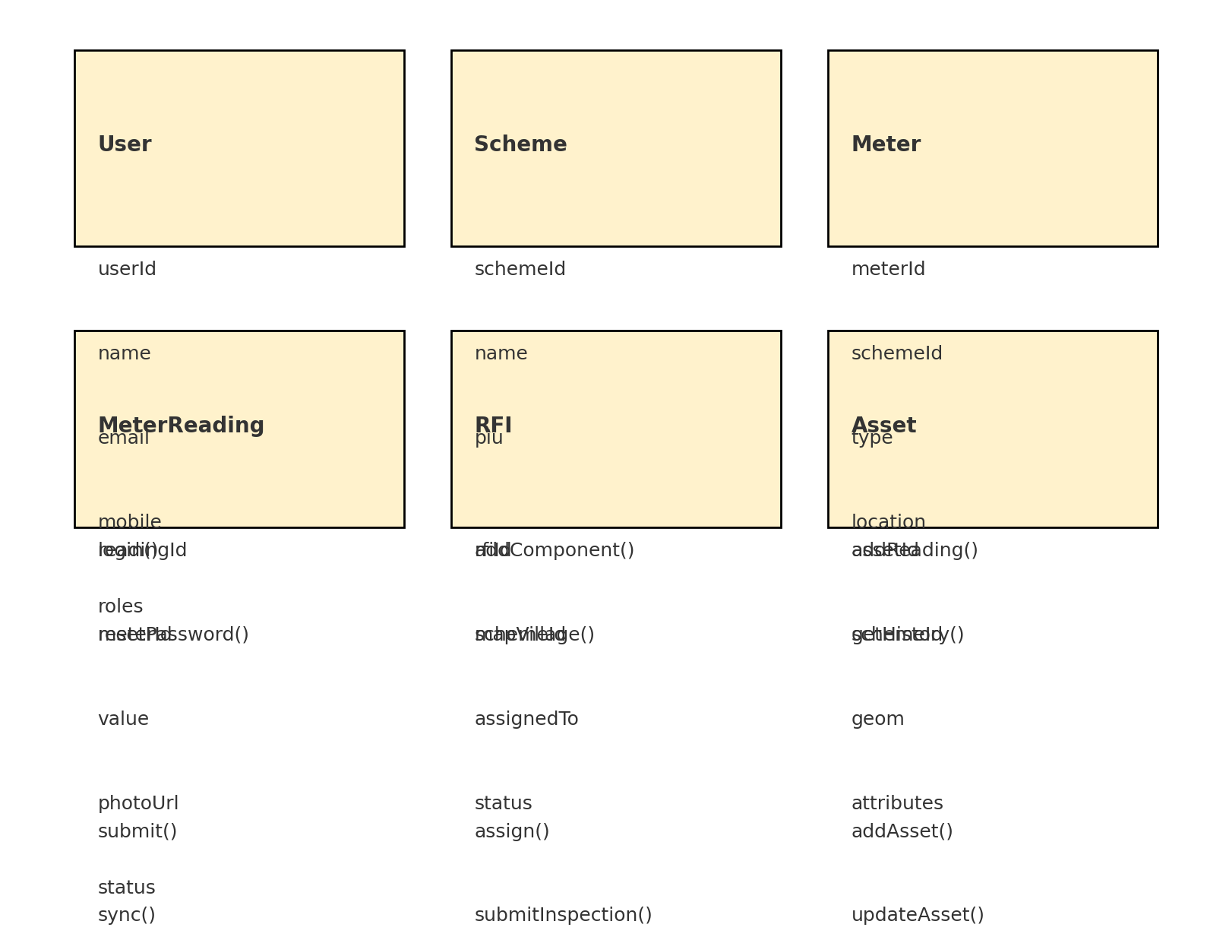
UML class model you can directly implement in Draw.io, PlantUML, or any UML tool and then color by sub-domain (User/Master, Asset & Metering, RFI/Quality, Planning & Reporting). I will give it in a textual class-diagram style so you can convert it visually.

Package Structure (for coloring)
- Package master (color 1): User, Role, Scheme, Component, Village.
- Package metering (color 2): Meter, MeterReading, MeterHistory.
- Package rfi (color 3): RFI, RFIInspection, RFIHistory.
- Package asset (color 4): Asset, AssetLocation.
- Package quality (color 5): WaterTest, LabReport.
- Package work (color 6): WorkPlan, WorkProgress.
- Package dashboard (color 7): KPIService, ReportGenerator (optional service classes).
You can assign one color per package in your tool to get a “colorful” diagram.

Class Definitions (Attributes & Methods)
master::User
- Attributes
  - userId: Long
  - name: String
  - email: String
  - mobile: String
  - status: UserStatus (ACTIVE, INACTIVE, BLOCKED)
  - createdAt: DateTime
  - lastLoginAt: DateTime
- Methods
  - authenticate(password: String): boolean
  - assignRole(role: Role): void
  - deactivate(): void
master::Role
- Attributes
  - roleId: Long
  - roleName: String // ADMIN, GM, SQC, TPIA, FE, PIU_USER
  - permissions: List<String>
- Methods
  - addPermission(permission: String): void
  - removePermission(permission: String): void
master::Scheme
- Attributes
  - schemeId: Long
  - schemeName: String
  - piu: String
  - startDate: Date
  - status: SchemeStatus (PLANNED, ACTIVE, COMPLETED, ON_HOLD)
- Methods
  - activate(): void
  - complete(): void
master::Component
- Attributes
  - componentId: Long
  - scheme: Scheme
  - type: ComponentType // INTAKE, WTP, OHT, PIPELINE, ESR, VALVE, VILLAGE_POINT
  - attributesJson: String // diameter, material, etc.
  - status: String
- Methods
  - updateAttributes(attrsJson: String): void
master::Village
- Attributes
  - villageId: Long
  - name: String
  - scheme: Scheme
  - population: Integer
  - waterDemand: Double

metering::Meter
- Attributes
  - meterId: Long
  - scheme: Scheme
  - type: MeterType // INTAKE, WTP, OHT, VILLAGE_SUPPLY, BULK_CONSUMER
  - location: String
  - installedDate: Date
  - status: MeterStatus (ACTIVE, FAULTY, DECOMMISSIONED)
- Methods
  - markFaulty(): void
  - deactivate(): void
metering::MeterReading
- Attributes
  - readingId: Long
  - meter: Meter
  - value: Double
  - unit: String // m3, KL
  - photoUrl: String
  - remarks: String
  - fe: User
  - submittedDate: DateTime
  - status: ReadingStatus (PENDING, VERIFIED, REJECTED)
  - verifiedBy: User
- Methods
  - verify(verifier: User): void
  - reject(verifier: User, reason: String): void
metering::MeterHistory
- Attributes
  - logId: Long
  - reading: MeterReading
  - action: String // CREATED, VERIFIED, REJECTED
  - actionBy: User
  - timestamp: DateTime
  - remarks: String

rfi::RFI
- Attributes
  - rfiId: Long
  - scheme: Scheme
  - component: Component
  - createdBy: User
  - assignedTo: User // FE
  - status: RFIStatus (CREATED, ASSIGNED, INSPECTED, APPROVED, REJECTED)
  - createdDate: DateTime
  - updatedDate: DateTime
- Methods
  - assignTo(fe: User): void
  - updateStatus(status: RFIStatus): void
rfi::RFIInspection
- Attributes
  - inspectionId: Long
  - rfi: RFI
  - fe: User
  - photos: List<String>
  - remarks: String
  - gpsLat: Double
  - gpsLong: Double
  - status: InspectionStatus (SUBMITTED, UNDER_REVIEW, APPROVED, REWORK)
  - submittedDate: DateTime
- Methods
  - submit(): void
rfi::RFIHistory
- Attributes
  - logId: Long
  - rfi: RFI
  - action: String // ASSIGNED, SUBMITTED, APPROVED, REJECTED
  - actionBy: User
  - remarks: String
  - timestamp: DateTime

asset::Asset
- Attributes
  - assetId: Long
  - scheme: Scheme
  - type: AssetType // PIPELINE, OHT, ESR, VALVE, JUNCTION, RESERVOIR, BPT
  - attributesJson: String
  - status: String
  - createdDate: DateTime
- Methods
  - updateStatus(status: String): void
asset::AssetLocation
- Attributes
  - asset: Asset
  - geom: Geometry // Point / LineString / Polygon (PostGIS)
- Methods
  - updateGeometry(geom: Geometry): void

quality::WaterTest
- Attributes
  - testId: Long
  - scheme: Scheme
  - component: Component
  - fe: User
  - parametersJson: String // pH, TDS, etc.
  - photoUrl: String
  - status: TestStatus (PENDING_LAB, UNDER_REVIEW, APPROVED, UNSAFE)
  - collectionDate: DateTime
- Methods
  - markUnsafe(): void
quality::LabReport
- Attributes
  - reportId: Long
  - test: WaterTest
  - fileUrl: String
  - uploadedBy: User
  - uploadedDate: DateTime

work::WorkPlan
- Attributes
  - planId: Long
  - scheme: Scheme
  - component: Component
  - contractorId: Long
  - plannedStart: Date
  - plannedEnd: Date
  - approvedBy: User
  - status: WorkPlanStatus (DRAFT, APPROVED, IN_PROGRESS, COMPLETED)
- Methods
  - approve(approver: User): void
  - markInProgress(): void
  - complete(): void
work::WorkProgress
- Attributes
  - progressId: Long
  - plan: WorkPlan
  - actualStart: Date
  - actualEnd: Date
  - progressPercent: Double
  - photoUrl: String
  - remarks: String
- Methods
  - updateProgress(percent: Double): void

dashboard::KPIService (service class)
- Methods
  - getSchemeKPI(schemeId: Long): KPISnapshot
  - getRFIStats(schemeId: Long): RFIStats
  - getWaterQualityTrends(schemeId: Long): List<TrendPoint>
dashboard::ReportGenerator (service class)
- Methods
  - generateMeterReport(schemeId: Long, dateRange: DateRange): ReportFile
  - exportWorkProgressReport(schemeId: Long): ReportFile

Relationships (for your UML tool)
- User 1..* — 0..* Role (via association class or user_role_map).
- Scheme 1 — 0..* Component.
- Scheme 1 — 0..* Meter.
- Scheme 1 — 0..* Asset.
- Scheme 1 — 0..* WaterTest.
- Scheme 1 — 0..* WorkPlan.
- Component 1 — 0..* WaterTest, 1 — 0..* WorkPlan.
- Meter 1 — 0..* MeterReading; MeterReading 1 — 0..* MeterHistory.
- RFI 1 — 0..* RFIInspection; RFI 1 — 0..* RFIHistory.
- Asset 1 — 1 AssetLocation.
- WorkPlan 1 — 0..* WorkProgress.
- WaterTest 1 — 0..* LabReport.
In your UML tool (e.g., draw.io, PlantUML, Canva whiteboard), you can:
- Group classes by package and apply a distinct color per group (master, metering, rfi, asset, quality, work, dashboard).
- Use solid lines with multiplicities for associations, and add stereotypes (e.g., «service») for KPIService and ReportGenerator.

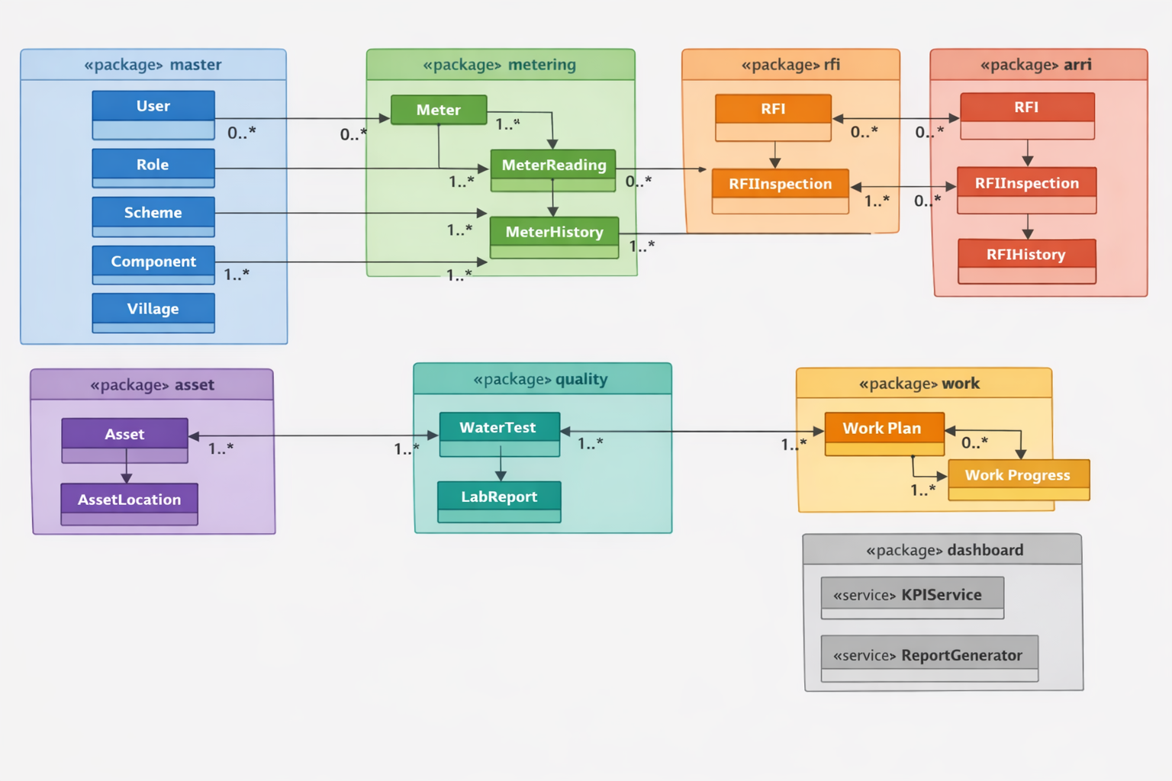

8. API Contracts (JSON / XML examples)
POST /api/user/create - Create User (Request JSON):
{
"name": "Ankur Shrivastava",
"email": "ankur@example.com",
"mobile": "9999999999",
"roles": [
"PIU_USER",
"GM"
]
}
Response (JSON):
{
"status": "success",
"userId": 1234,
"message": "User created successfully"
}
XML Request example:
<UserCreateRequest>
<name>Ankur Shrivastava</name>
<email>ankur@example.com</email>
<mobile>9999999999</mobile>
<roles>
<role>PIU_USER</role>
<role>GM</role>
</roles>
</UserCreateRequest>
POST /api/meter/reading - Submit Meter Reading (Request JSON):
{
"meterId": 987,
"value": 12345,
"unit": "m3",
"feId": 432,
"timestamp": "2024-02-20T10:30:00Z",
"photoUrl": "https://example.com/photo.jpg",
"remarks": "Routine reading"
}
Response (JSON):
{
"status": "success",
"readingId": 5555,
"message": "Reading submitted and pending verification"
}
POST /api/rfi/submit - Submit RFI Inspection (Request JSON):
{
"rfiId": 2001,
"feId": 432,
"photos": [
"https://example.com/rfi1.jpg"
],
"remarks": "Inspection completed, found alignment issue",
"gps": {
"lat": 23.25,
"lon": 77.41
}
}
Response (JSON):
{
"status": "success",
"inspectionId": 3001,
"message": "Inspection submitted"
}

9. Appendix - Table Schemas (DDL style)
Sample DDL snippets for core tables (PostgreSQL):
CREATE TABLE user_master (
user_id SERIAL PRIMARY KEY,
name VARCHAR(200) NOT NULL,
email VARCHAR(200) UNIQUE NOT NULL,
mobile VARCHAR(20) UNIQUE,
role_id INT,
status VARCHAR(20),
created_at TIMESTAMP DEFAULT now()
);
CREATE TABLE scheme_master (
scheme_id SERIAL PRIMARY KEY,
scheme_name VARCHAR(255) NOT NULL,
piu VARCHAR(200),
start_date DATE,
status VARCHAR(20)
);
CREATE TABLE meter_master (
meter_id SERIAL PRIMARY KEY,
scheme_id INT REFERENCES scheme_master(scheme_id),
type VARCHAR(50),
location VARCHAR(255),
installed_date DATE
);

10. Module-wise Low-Level Design

10.1 Anushravan (Inspection & RFI Workflow)
Database Tables
rfi_master(rfi_id, scheme_id, assigned_to, status, created_by, created_date, updated_date)
rfi_inspection(inspection_id, rfi_id, fe_id, photos, remarks, gps_lat, gps_long, status, submitted_date)
rfi_history(log_id, rfi_id, action, action_by, remarks, timestamp)
APIs
POST /rfi/assign → Assign RFI to FE
GET /rfi/list?status=Pending → Fetch RFI list
POST /rfi/submit → Submit inspection (photos + remarks)
POST /rfi/approve → Approve/Reject inspection
Workflow
- PIU User creates/assigns RFI.
- FE receives task → uploads inspection data.
- GM/TL reviews → approves/rejects.
- Status logged in rfi_history.

10.2 Dhara (Meter Reading & Verification)
Database Tables
meter_master(meter_id, scheme_id, type, location, installed_date, status)
meter_reading(reading_id, meter_id, value, photo_url, remarks, fe_id, submitted_date, status, verified_by)
meter_history(log_id, reading_id, action, action_by, timestamp)
APIs
POST /meter/add → Register new meter
POST /meter/reading → Upload meter reading
GET /meter/report?scheme_id&date_range → Generate report
Workflow
- Admin registers meters.
- Tasks assigned to FE.
- FE uploads reading + photo.
- GM verifies/rejects → contractor billing uses verified readings.

10.3 Asset Mapping (GIS-based Asset Capture)
Database Tables
asset_master(asset_id, scheme_id, type, attributes, created_date, status)
asset_location(asset_id, geom geometry(Point/Line/Polygon))
APIs
POST /asset/add → Create asset with geo-coordinates
GET /asset/list?scheme_id&type → List assets on map
POST /asset/uploadKML → Upload shapefile/KML
Workflow
- FE maps asset in mobile app → syncs coordinates + photo.
- Web app overlays survey data vs uploaded KML.
- Admin can query/filter assets on GIS map.

10.4 Nirmal (Water Quality Monitoring)
Database Tables
water_test(test_id, scheme_id, component_id, fe_id, parameters(json), photo_url, status, date)
lab_report(report_id, test_id, file_url, uploaded_by, uploaded_date)
APIs
POST /water/test → Record FE water quality parameters
POST /water/labreport → Upload lab report
POST /water/approve → QA/QC approval
Workflow
- FE enters field parameters + photo.
- Lab uploads report.
- QA/QC approves/rejects → alerts on unsafe results.

10.5 Sopan (Work Monitoring & Planning)
Database Tables
work_plan(plan_id, scheme_id, component_id, contractor_id, planned_start, planned_end, approved_by, status)
work_progress(progress_id, plan_id, actual_start, actual_end, progress_percent, photo_url, remarks)
APIs
POST /work/plan → Create plan
POST /work/progress → Update progress
GET /work/report?scheme_id → Work monitoring reports
Workflow
- Contractor creates work plan.
- GM approves/rejects plan.
- FE uploads progress data + photo.
- Reports and Gantt charts generated.

10.6 Master (Scheme, Components, Villages, Roles)
Database Tables
scheme_master(scheme_id, scheme_name, piu, start_date, status)
component_master(component_id, scheme_id, type, attributes)
village_master(village_id, name, scheme_id)
role_master(role_id, role_name, permissions)
APIs
POST /scheme/add → Add scheme
POST /component/add → Add component
POST /village/map → Map villages to scheme
POST /role/add → Define roles

10.7 User Management
Database Tables
user_master(user_id, name, email, mobile, role_id, status)
user_role_map(user_id, role_id)
APIs
POST /user/create → Create new user
POST /user/role/assign → Assign role
POST /user/deactivate → Deactivate user

10.8 Dashboard & Reporting
Data Sources
Aggregated queries from RFI, meter readings, water tests, work progress.
APIs
GET /dashboard/kpi?scheme_id → Fetch KPIs
GET /dashboard/trend?parameter → Fetch trends
Workflow
- KPIs aggregated from transactional tables.
- Dashboard displays scheme-wise, role-wise KPIs.
- Export available in XLSX/PDF.

11. Error Handling
- API request validation (mandatory fields, value ranges).
- Graceful fallback for offline → sync scenarios.
- Audit logging for all CRUD and approval actions.

12. Security
- Role-based access control (RBAC).
- Token-based authentication (JWT).
- Data encryption at rest (PostgreSQL TDE) and in transit (HTTPS/TLS).

13. Sequence Diagrams (to be included)
- RFI Assignment → Inspection Submission → Approval.
- Meter Reading Capture → Verification.
- Work Plan Creation → Approval → Progress Update.

